Title | Enterprising Doncaster
Reports to | Team Doncaster Strategy Partnership
Accountable for following Subgroups | Work and Skill Board
Signup of Partnership Charter | Yes

Team Doncaster Strategic Partnership

Enterprising Doncaster is one of four theme boards that sit within the Team Doncaster Strategic Partnership.

Team Doncaster is the Local Strategic Partnership for Doncaster that is dedicated to improving the quality of life for those who live, work and come to visit the borough.

The partnership brings together public sector organisations, voluntary and community groups, and local businesses to discuss the key issues which affect Doncaster to work towards key objectives – they are:

- Develop the vision and priorities for the area through the Borough Strategy;
- Agree the delivery plan and detailed outcomes for development of Doncaster.

Structure
The structure of the Team Doncaster Strategic Partnership is as follows.

ENTERPRISING DONCASTER PURPOSE
To provide robust strategic leadership for the economic agenda and deliver the Economic Growth Plan in true partnership with the private sector.

STRATEGIC AIMS

- Influence the direction of the Doncaster economy through participation in the development of the borough’s economic priorities.

- Understand and articulate the needs of the business community.

- Raise awareness of the positive impact that economic success has on the achievement of other local priorities, enabling access to opportunities and increasing the quality of life of local people, through the promotion of the “what the economy can do for you” message.

- Bring together the demand and supply sides of the local labour market in efforts to raise employability, skill levels and promote enterprise.

- Put employer needs at the heart of employability, skills and enterprise programmes to improve employment rates, skill levels and promote enterprise.

- To influence and challenge agencies to ensure resources are effectively aligned to support employability, skills and enterprise objectives.

- Command confidence in private, public and voluntary/community/faith sectors.

OUTCOME FRAMEWORK
Outcomes:
- Grow the number of and productivity of Doncaster businesses.
- Harness and enhance Doncaster’s assets.
- Improve connectivity.
- Ensure residents have the skills and abilities firms need.
Functions
To draw upon the expertise of the private sector when and if required to drive delivery, influence policy, and constructively challenge partners. Enhance the economic landscape of Doncaster through partnership working.

OPERATING PRINCIPLES
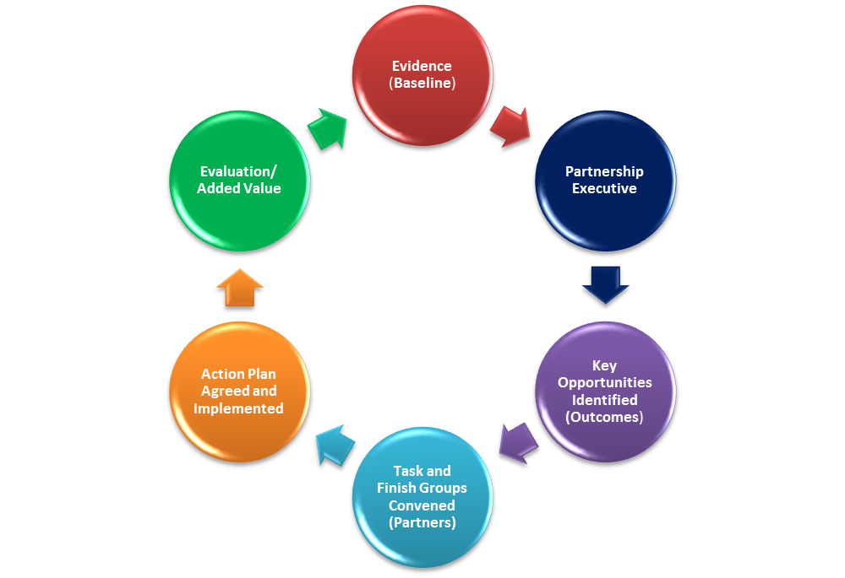
- Enterprising Doncaster will be accountable to the Team Doncaster Strategic Partnership.
- Enterprising Doncaster will support the delivery of Doncaster’s Economic Growth Plan.
- Any activity commissioned by Enterprising Doncaster will have a clear and defined purpose.
- Outcome based accountability will be at the heart of Enterprising Doncaster, providing an evidence based platform for private sector discussion, challenge or action.
- Evaluation of partnership activity will be grounded in OBA: what difference has the partnership made?
Enterprising Doncaster is a private and public sector partnership set to deliver the Economic Growth Plan to benefit the residents and businesses of Doncaster.
Outcome based accountability (OBA) is at the heart of the Enterprising Doncaster Partnership. OBA provides and evidence based platform for private sector challenge, intervention and additionality.
The partnership executive considers all the economic agenda and uses the OBA turning the curve reports to identify areas of the Growth Plan delivery that could benefit from private sector discussion, challenge or action. Once an area has been agreed by the partnership executive a call to the private sector and relevant experts will be made to attend a subject specific meeting, which has been labelled a task and finish groups. See below.
Every six months a general meeting will be held with all Enterprising Doncaster members. This will work and engagement tool to keep all members:
- informed on progress of current task and finish groups;
- interrogate the OBA performance reports and expand using anecdotal evidence from the business community.
- Celebrate and share good news and success from Enterprising Doncaster activity and the wider partnership.
Sub Groups
Work and Skills Board is an ongoing and well established sub group of Enterprising Doncaster. Outcome based accountability is at the heart of the groups performance management and therefore fits directly with the format of Enterprising Doncaster. The focus of this board is: apprenticeships; upskilling; graduates; and employability. Enterprising Doncaster will retain the accountability of the whole population for skills whereas the Work and Skills Board will be held accountable for the client population and performance management.
Other key issues will be dealt with by the way of task and finish groups (see below).
Task and finish groups
Task and finish groups will be provided with a clear purpose and objective but will have no time limitation placed upon them. Once the objective has been achieved the task and finish group will disband. Task and finish groups will be accountable to the partnership executive who will evaluate the activity. Evaluation of task and finish groups will be simple: what difference did the activity/discussion make? If the answer to this evaluation is little to no difference then the task and finish group will be disbanded and a new approach taken to try and achieve the objective. This decision will sit with the partnership executive.
MEMBERSHIP
Appointment of Chair
- The chair of Enterprising Doncaster is advertised publically and expressions of interest invited from the business community. These are then shortlisted and interviewed by the economic portfolio holder and a chief officer from a partnership organisation.
- The chair should be independent.
- The appointment of the chair will last for two years.
Appointment of Members
- Board members will be recruited from the private sector via an interview process.
- Seats will be advertised publically.
- Interviews will be conducted by the chair or vice chair of the board.
- Membership will be reviewed after two years.
- Members of the business community, agenda experts and other partnership members (from within Team Doncaster) will be invited and welcomed to attend task and finish groups. This does not automatically give them Board Member Status.
- Enterprising Doncaster Board members are asked to attend Board Meetings wherever possible and contribute where relevant to task and finish groups.
Statutory bodies required
The economic partnership is not a statutory partnership and therefore has no statutory bodies required.
Non Statutory bodies
The partnership should consist of, at a minimum, representation from: the local authority, the local chamber and local economic partnership. Members will be invited to join Enterprising Doncaster from the business community. Task and finish groups will invite those relevant to the subject specific objective to be discussed or actioned dependent upon their expertise or interest, they do not need to be an Enterprising Doncaster Board member.
Review
Membership will be under constant review due to the operating principles of Enterprising Doncaster, keeping membership relevant and able to make a difference.
A review of the Partnership Executive membership will take place bi-annually after the appointment of the Chair of Enterprising Doncaster.
Attendance Required
A minimum of four members of the Partnership Executive need to be present for Enterprising Doncaster decisions to be ratified.
Meeting dates /frequency
There will be a six monthly Enterprising Doncaster meeting where all outcomes will be reviewed and further opportunities identified.
The partnership executive will meet on a bi-monthly basis to discuss key issues and draw together task and finish groups when required.
Task and finish groups will meet when required to progress issues and deliver against a particular objective.
LEGISTRATION
Performance Management
Performance management of Enterprising Doncaster will take the structure outlined in Outcome Based Accountability (OBA). It will be directly linked to Doncaster’s Economic Growth Plan and essentially the Borough Strategy.
Enterprising Doncaster Partnership Executive will have an overview of the entire OBA framework but the board will retain whole population accountability with client and performance accountability falling to the relevant sub groups or task and finish groups.
Reporting Procedures
Enterprising Doncaster will be accountable to Team Doncaster and will report directly to the Strategic Partnership.
ETHICS AND CODE OF CONDUCT
Partnership Charter
Enterprising Doncaster signed the Partnership Charter early 2014. Members are asked to abide by the standards and ethos of the Partnership Charter at all times.
Conflict of Interest Register
All members of Enterprising Doncaster will complete a Conflict of Interest form to be inputted on to the Conflict of Interest Register.
Member Expenses
No member expenses will be paid unless exceptional circumstances and agreed prior to the expense being accrued.

APPROVED LIST OF MEMBERS
Partnership Executive:
Nigel Brewster – Brewster Pratap Recruitment Group – LEP Skills Lead – Chair
Dan Fell – Doncaster Chamber CEO – Vice Chair
Peter Dale – Director of Regeneration and Environment
Scott Cardwell – Assistant Director of Development
Economic Portfolio Holder – TBC
Partnership Board
Cheryl Williams – Yorkshire Wildlife Park
Chris Weatherall – Wabtec
Jim Wren – Strata Homes
Peter Kersh – New Era
Richard McIlroy – Mount Pleasant Hotel
Richard Wrigley – BETA Technology
Richard Walsh – Pennine Stone
Roger Allen – Don valley Engineering
Simon English – Hannah Reed
Steve Gill – Peel Airport
Tariq Shah – Vigo
Howard O’Neill – Hull LEP
George Trow – Doncaster College

TofR Approved | Date | Review and Updating TofR | Date

